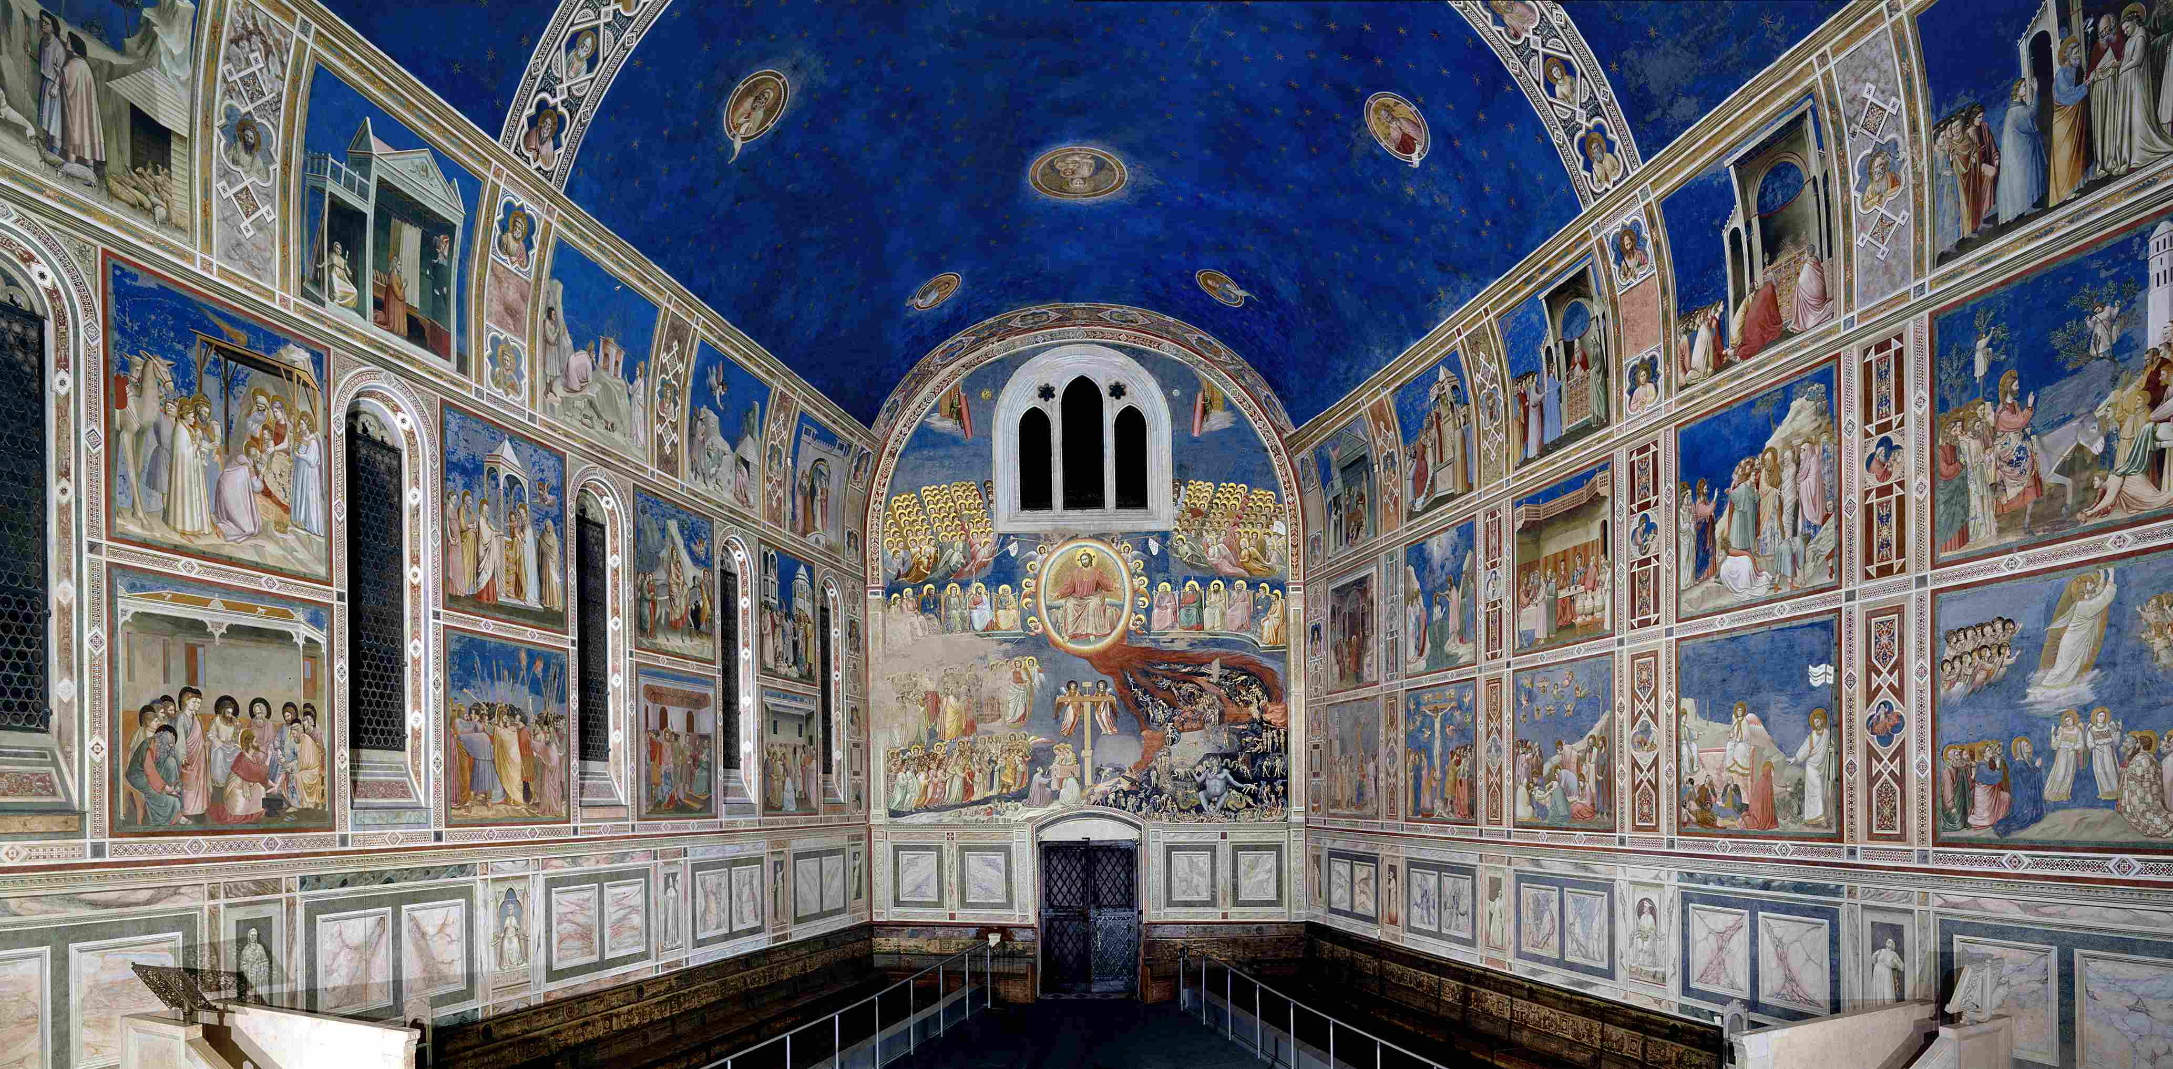
ISTITUTO COMPRENSIVO DI SOCI
Scuola Secondaria di Primo Grado

CLIL PROJECT: GIOTTO
school year 2016-2017

Boldrini Gigliola (English teacher)
Barbagli Sonia (Art teacher)

Classes: 2A, 2B
Unit 1 | GIOTTO DA BONDONE
Level 2nd classes (A2) | Lessons 4 | Lessons timing 60’ |  | Unit timing 4h
AIMS |  |  | ASSESSMENT
To introduce the students in the world of Art in English  To learn about famous painters, their artworks and the art movement  To learn about Giotto’s life, techniques, masterpieces |  |  | Self assessment  Teacher assessment
Teaching objectives |  |  | Materials
To know the artist, his life, his masterpieces and their features  To know his innovation in the world of art  To strengthen comunicative competence in different contexts in order to acquire disciplinary content and to be able to develop critical thoughts  To observe and compare data and / or information  To select and classify data and / or information  To listen and understand specific information  To read and understand descriptive texts to obtain specific information |  |  | Video http://www.italian-renaissance-art.com/Giotto.html  Worksheet 1: Biography of Giotto  Worksheet 2: Grid to fill in  Glossary
Basic competences/SKILLS
Communicative

- To improve linguistic and audio-visual competences
- To improve comunicative competences in artistic and cultural fields
- To ask and give simple information about the artist and his paintings
- To understand, perceive and to be able to value, critically, different cultural and artistic forms of expression

Methodological

- Learning to learn: to apply study skills that include strategic thinking, cooperation and self-evaluation skills
- Problem solving
- To develop meta-cognitive reflection and cognitive self-assessment
- To identify, select and group

Personal

- To improve autonomy, initiative and decision taking
- To develop creativity in carrying out projects
- To strengthen and improve logical skills for hypotheses and deductions

LEARNING OUTCOMES
Content |  | Cognition
To introduce the artist to the students  To know Giotto’s biography and discuss about it  To know his masterpieces and techniques |  | Brainstorming  Reading and answer questions - Key vocabulary  Fill in a grid in the lab  Match the words/expressions - Listen and complete…  Find the differences/Compare  Speaking: introduce the topic
Culture
Awareness of the main features in Giotto’s masterpieces
Make comparisons between Giotto’s new ideas and the previous concept of art
To be able to analyse a work of art and appreciate its artistic value

Communication
Learn to comunicate and exchange ideas about Giotto, his technique, the new idea of art

Language OF learning | Language FOR learning |  | Language THROUGH learning
Key words  Expressions for describing paintings | Locating things/people in describing a landscape, a scenery  Speaking about colours, art techniques  Making comparaisons (between two paintings)  Expressing opinion, feelings |  | Give instructions  Language in classroom activities

Unit 2 | GIOTTO DA BONDONE: analysis of the fresco cycles in the Scrovegni Chapel (Padua)
Level 2nd classes  (A2) | Lessons 4 | Lessons timing 60’ |  | Unit timing 4h
AIMS |  |  | ASSESSMENT
To learn about famous painters, their artworks and the art movement |  |  | Self assessment  Teacher assessment
Teaching objectives |  |  | Materials
To know the artist, his life, his masterpieces and their features  To know his innovation in the world of art  To be able to read and analyse the fresco cycles, describe the scenes and discuss about that |  |  | Video  Worksheet 1: Biography of Giotto  Glossary  Reproduction of the cycle of frescoes in the Scrovegni Chapel (Padua)
Basic competences/SKILLS
Communicative

- To improve linguistic and audio-visual competences
- To improve comunicative competences in artistic and cultural fields
- To ask and give simple information about the artist and his paintings, in particular about the fresco cycles in Padua
- To understand, perceive and to be able to value, critically, different cultural and artistic forms of expression

Methodological

- Learning to learn: to apply study skills that include strategic thinking, cooperation and self-evaluation skills
- Problem solving
- To develop meta-cognitive reflection and cognitive self-assessment
- To identify, select and group

Personal

- To improve autonomy, initiative and decision taking
- To develop creativity in carrying out projects
- To strengthen and improve logical skills for hypotheses and deductions

LEARNING OUTCOMES
Content |  | Cognition
To analyse “The mourning of the dead Christ” in detail  To be able to understand a painting and describe it to the classmates  To be able to understand all the fresco cycles in the Scrovegni Chapel  To apply art vocabulary and artistic concepts  To analyse and compare artworks by different artists  To reproduce one of the depicted scenes and to be able to describe it |  | Brainstorming  Reading and answer questions - Key vocabulary  Fill in a grid in the lab  Match the words/expressions - Listen and complete  Find the differences/Compare  Analyse other masterpieces and describe them  Speaking: introduce the introduced topic (one chosen scene of the fresco) to the class
Culture
Awareness of the main features in Giotto’s masterpieces
Make comparisons between Giotto’s new ideas and the previous concept of art
To be able to analyse a work of art and appreciate its artistic value
To respect and value different artist’s works

Communication
Learn to comunicate and exchange ideas about Giotto, his technique, the new idea of art

Language OF learning | Language FOR learning |  | Language THROUGH learning
Key words  Expressions and words for describing paintings | Locating things/people in describing a landscape, a scenery  Speaking about colours, art techniques  Making comparaisons (between two paintings)  Expressing opinion, feelings |  | Give instructions  Language in classroom activities

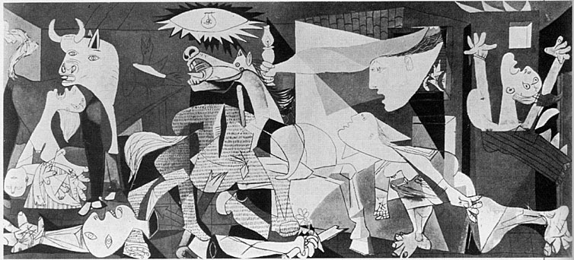
ISTITUTO COMPRENSIVO DI SOCI
Scuola Secondaria di Primo Grado

CLIL PROJECT: PICASSO
school year 2016-2017

Boldrini Gigliola (English teacher)
Barbagli Sonia (Art teacher)
Classes: 3A, 3B
Unit 1 | PABLO PICASSO: life, techniques, masterpieces
Linguistic Level A2/B1(3rd classes ) | Lessons 2 | Lessons timing 60’ |  | Unit timing 2h
AIMS |  |  | ASSESSMENT
To learn about famous painters, their artworks and the art movement |  |  | Self assessment  Teacher assessment
Teaching objectives |  |  | Materials
To know the artist, his life, his masterpieces and their features  To know his innovation in the world of art  To strengthen comunicative competence in different contexts in order to acquire disciplinary content and to be able to develop critical thoughts  To observe and compare data and / or information  To select and classify data and / or information  To listen and understand specific information  To read and understand descriptive texts to obtain specific information  To answer written questions, complete texts, tables, know and use the specific vocabulary on Cubism, Art and Image |  |  | Video http://www.raiscuola.rai.it  PPP: Picasso:from his early formation to surrealism  Worksheet 1: Read and match  Worksheet 2: Fill in a grid  Glossary
Basic competences/SKILLS
Communicative

- To improve linguistic and audio-visual competences
- To improve comunicative competences in artistic and cultural fields
- To ask and give simple information about the artist, his career and his paintings
- To understand, perceive and to be able to value, critically, different cultural and artistic forms of expression

Methodological

- Learning to learn: to apply study skills that include strategic thinking, cooperation and self-evaluation skills
- Problem solving
- To develop meta-cognitive reflection and cognitive self-assessment
- To identify, select and group

Personal

- To improve autonomy, iniziative and decision taking
- To develop creativity in carrying out projects
- To strengthen and improve logical skills for hypotheses and deductions

LEARNING OUTCOMES
Content |  | Cognition
To introduce the artist to the students.  To read and learn his artistic life, the remarkable periods in his career, to learn about Cubism and its features.  To be able to understand a work of art, identify compositional elements, use of special technique for creative tasks and describe it to the classmates |  | Identifying, classifying, analyzing, synthesizing and evaluating painting elements
Culture
Awareness of Picasso’s life, the evolution in his career, the main features in his masterpieces
Being aware of the role of Cubism
To be able to analyse a work of art and appreciate its artistic value

Communication
Learning to comunicate and exchange ideas about Picasso, his technique, the new idea of art
Developing new vocabulary related to the language of art and drawing
Using new acquired vocabulary in context

Language OF learning | Language FOR learning |  | Language THROUGH learning
Key words  Describing paintings | Locating things/people in describing a landscape, a scenery  Speaking about colours, art techniques  Making comparaisons (between two paintings)  Expressing opinions, feelings |  | Give instructions  Language in classroom activities

Unit 2 | PICASSO: GUERNICA
Level A2/B1  (3rd classes) | Lessons 2 | Lessons timing 60’ |  | Unit timing 2h
AIMS |  |  | ASSESSMENT
To learn about famous painters, their artworks and the art movement |  |  | Self assessment  Teacher assessment
Teaching objectives |  |  | Materials
To know the artist, his life, his masterpices and their features  To know his innovation in the world of art  To watch and read an artwork from the early twentieth century: Guernica di Picasso, to learn about Cubism  To be able to analyse the painting, to describe the main features, symbols and discuss about that |  |  | Video: youtube Guernica Pablo Picasso - Guernica (1937) Art History Online  Worksheet 1: Guided questions to peers  Worksheet 2: Grid to fill in  Worksheet 3: how to read the painting (grid to fill in about the symbols in the painting)  Glossary
Basic competences/SKILLS
Communicative

- To improve linguistic and audio-visual competences
- To improve comunicative competences in artistic and cultural fields
- To ask and give simple information about the artist and his paintings
- To understand, perceive and to be able to value, critically, different cultural and artistic forms of expression

Methodological

- Learning to learn: to apply study skills that include strategic thinking, cooperation and self-evaluation skills
- Problem solving
- To develop meta-cognitive reflection and cognitive self-assessment
- To identify, select and group

Personal

- To improve autonomy, initiative and decision taking
- To develop creativity in carrying out projects
- To strengthen and improve logical skills for hypotheses and deductions

LEARNING OUTCOMES
Content | Cognition
To read of a work of art of the early xxth century: a painting, Guernica by Picasso  To learn about Cubism  To create an artwork | Brainstorming  Reading and answer questions - Key vocabulary  Fill in a grid in the lab  Match the words/expressions  Listen and complete…  Find the symbols and write them in a grid  Find the differences/Compare  Speaking: introduce the painting to the class (explaining the images and the symbols)
Culture
Awareness of the main features in Picasso’s masterpieces
Make comparisons between Picasso’s new technique and the previous concept of art
To be able to analyse a work of art and appreciate its artistic value

Communication
Learn to communicate and exchange ideas about Picasso, his technique, the new idea of art
Talk about personal reactions in front of a work of art (like/dislike)

Language OF learning | Language FOR learning | Language THROUGH learning
Key words  Describing paintings | Locating things/people in describing a painting  Speaking about colours, art techniques  Expressing the value of symbolism and understand the used symbols  Making comparaisons (between two paintings of his production)  Expressing opinions, feelings | Give instructions  Language in classroom activities

