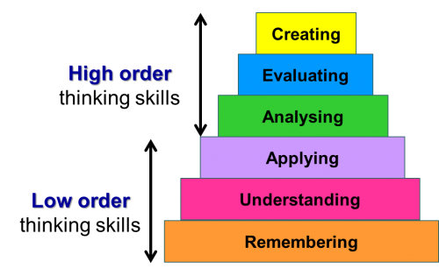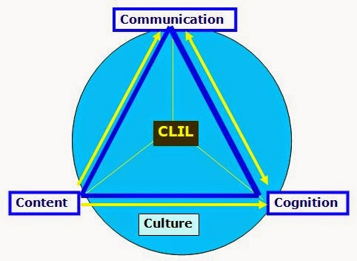**CLIL 4 C SCHEME HAROLD BLOOM’S TAXONOMY**